S.O.A.R.

Standing Out Above the Rest
Middle School Dorm Behavior Program
Louisiana School for the Deaf
2020 -2021

Behavior Program
INTRODUCTION to SOAR Behavior Program

Standing Out Above the Rest (SOAR) is the middle school residential life behavior program at LA School for the Deaf. Our behavior program uses a combination of both rewards for positive behavior and consequences for negative behavior to teach and encourage students to practice good behavior independently. SOAR also promotes maturity and responsibility.

PBIS
LSD uses a behavior instruction system called Positive Behavior Interventions and Supports (PBIS). This system has been established in research as an effective method for establishing cultural and behavioral support needed for all students to achieve social and academic success.
SOAR is a comprehensive behavior program that incorporates the Positive Behavior Interventions & Support (PBIS) for developing positive self-regulating behavior among middle school residential students. Through this program, students will learn to:
- Develop skills to recognize how one’s own behavior affects others
- Understand and use logical reasoning and problem-solving vocabulary
- Gain knowledge of and skills in the steps of social solving, leading to the prevention and/or resolution of problems and conflicts in daily life.
- Become self-advocates and exhibit leadership qualities
- Earn privileges and develop responsibility by demonstrating control over and ownership of their behavior by following established dorm expectations and policies.
The expectations for the dorm life are divided in three components: Obedience, Independence and
Courteous (OIC). The OIC expectations will be posted in each dorm with pictures and expectations.

Restorative Practices/Social and Emotional Learning:
Restorative Practices is a whole child approach designed to address student behavior by identifying and fulfilling needs and replacing punitive disciplinary practices with strategies, which build community and resolve interpersonal conflict.
Social and Emotional Learning (SEL) is the overall process by which students:
- - Understand and manage feelings
- - Relate appropriately with others
- - Deal with conflict(s) and other life challenges in a positive manner
- - Make good decisions
- - Transition from a school environment to the real world
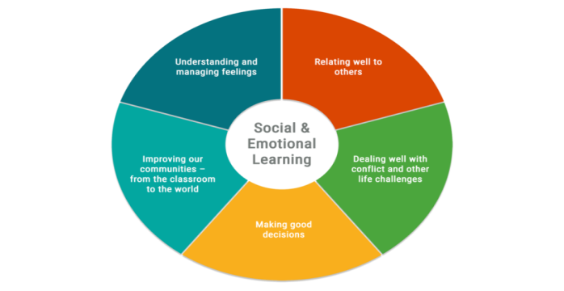

PATHS
The middle school dorm program uses the Promoting Alternative Thinking Strategies (PATHS) curriculum which will increase the students’ ability to understand social problems, develop effective alternative solutions, decrease the percentage of aggressive/violent situations, and increase the students’ understanding & recognition of emotions. Our goal is to instill in residential students a functional process that leads to an empowering sense of self-responsibility.
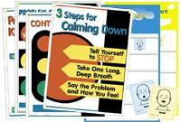

Moving Up/Down Levels
EAGLE

1 X

days
30

Level 1

3X

14
14
days

Level 2

3 X

5

days

Level 3

Place Status | Middle School
Moving Up or Down | UP | DOWN
Eagle | Eagle | 1X
Level 1 | 30 days | 3X
Level 2 | 14 days | 3X
Level 3 | 5 days
*Based on Two Week Behavior Tracking Chart*

LEVEL PRIVILEGES CHART
Privileges | E  A  G  L  E |  | L  E  V  E  L  1 |  | L  E  V  E  L  2 |  | L  E  V  E  L  3
RECREATION/SPORTS
Participate in social time listed on Activity Schedule | ✔ |  | ✔ |  | ✔ |  | ✔
Participate in school sports (athlete) | ✔ |  | ✔ |  | ✔ |  | ✔
Participate in school sports (fans) | ✔ |  | ✔ |  | ✔ |  | 🞬
Participate in Center activities | ✔ |  | ✔ |  | ✔ |  | 🞬
Participate in PEC activities | ✔ |  | ✔ |  | ✔ |  | 🞬
Participate on campus dorm activities | ✔ |  | ✔ |  | ✔ |  | 🞬
Participate off campus dorm activities | ✔ |  | ✔ |  | ✔ |  | 🞬
VIDEOPHONE/COMPUTER
Can use computer, laptop, and/or tablet |  | ✔ |  | ✔ |  | ✔  After supper |  | 🞬  Homework  only
Can use the telephone, videophone |  | ✔ |  | ✔ |  | ✔  After supper |  | 🞬  Parents only
MEAL/SNACKS
Earn PBIS snack |  | ✔ |  | ✔ |  | ✔ |  | 🞬
Can order food before 7:00 pm |  | ✔ |  | ✔ |  | 🞬 |  | 🞬
CELL PHONE/PAGER
Can bring cell phone/pager to school |  | ✔ |  | ✔ |  | 🞬 |  | 🞬
Get cell phone/pager after school |  | ✔ |  | ✔ |  | 🞬 |  | 🞬
Get cell phone/pager after dinner |  | ✔ |  | ✔ |  | ✔ |  | 🞬

Bedtime
Eagle | 10:00
Level One | 9:30
Level Two | 9:00
Level Three | 8:30

LOUISIANA SCHOOL FOR THE DEAF

MIDDLE SCHOOL DORMITORY

SOAR PROGRAM
STUDENT-PARENT CONTRACT

BEHAVIOR PROGRAM:

Parent/Guardian: (please initial)

____ I HAVE COMPLETELY READ AND FULLY UNDERSTAND THE SOAR PROGRAM AND AGREE TO FOLLOW THE GUIDELINES SET FORTH.

WORKSHOPS and ACTIVITIES:

____ I UNDERSTAND THAT SOAR. WORKSHOPS AND EDUCATIONAL ACTIVITIES REQUIRE STUDENT’S PARTICIPATION. I FULLY AGREE THAT MY CHILD WILL ATTEND THESE WORKSHOPS AND ACTIVITIES SPONSORED BY THE SOAR PROGRAM.

----------------------------------------------------------------------------------------------------------------------------------------------------

Students: (please initial)

NOTE: STUDENTS HAVE RECEIVED AN EXPLANATION OF THE SOAR PROGRAM THROUGH SIGN LANGUAGE OR PREFERRED COMMUNICATION MODE.

____ I ALSO UNDERSTAND THAT SIGNING THIS AGREEMENT WILL MEAN THAT I WILL SUPPORT THE PRIVILEGES AND CONSEQUENCES OF THE SOAR PROGRAM.
----------------------------------------------------------------------------------------------------------------------------------------------------

SIGNATURES:

STUDENT Date

PARENT/GUARDIAN Date

STUDENT DEVELOPMENT SPECIALIST Date

PLEASE SIGN AND RETURN TO:

Student Development Specialist
Middle School Dorm
Louisiana School for the Deaf
P.O. Box 3074
Baton Rouge, LA 70821-3074
FAX (225) 757-3428

